Technology Training at Winhe SEA

Exercise – 1

1. Channeling Doctors/Consultants in Sri Lanka
   1. Eco-Channeling
   2. Order Medicines
   3. Lab Tests
   4. Chat Consultants
   5. Patients
   6. Consultants
   7. Patients – Provide Medical Consultants/ Channel Doctors/ Order Medicines
   8. Consultants - Meet patients online and give consults.
   9. Doc 990
   10. Nawaloka Channeling
2. 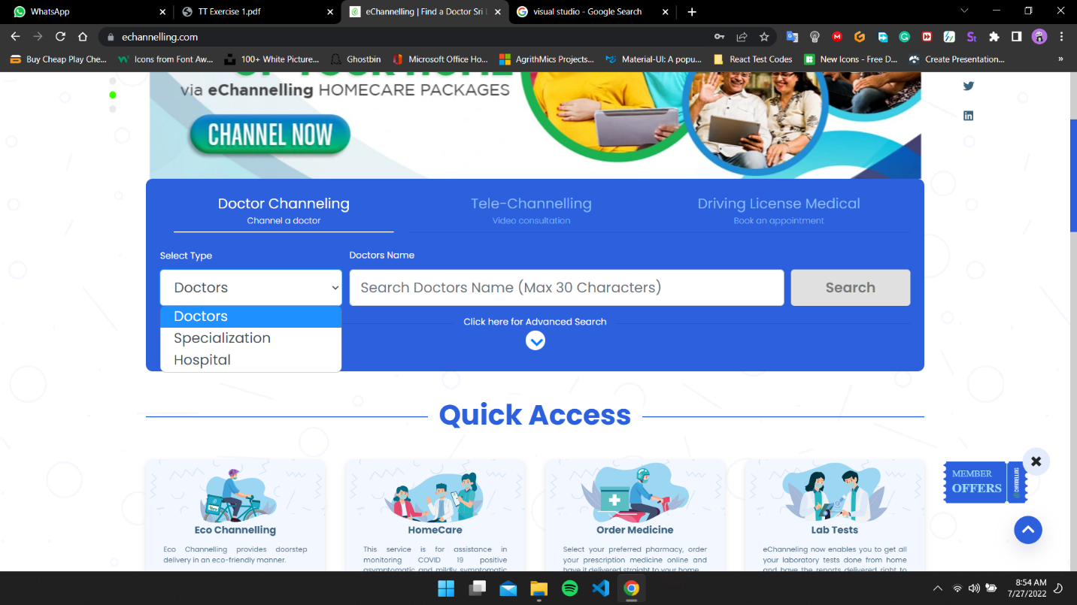

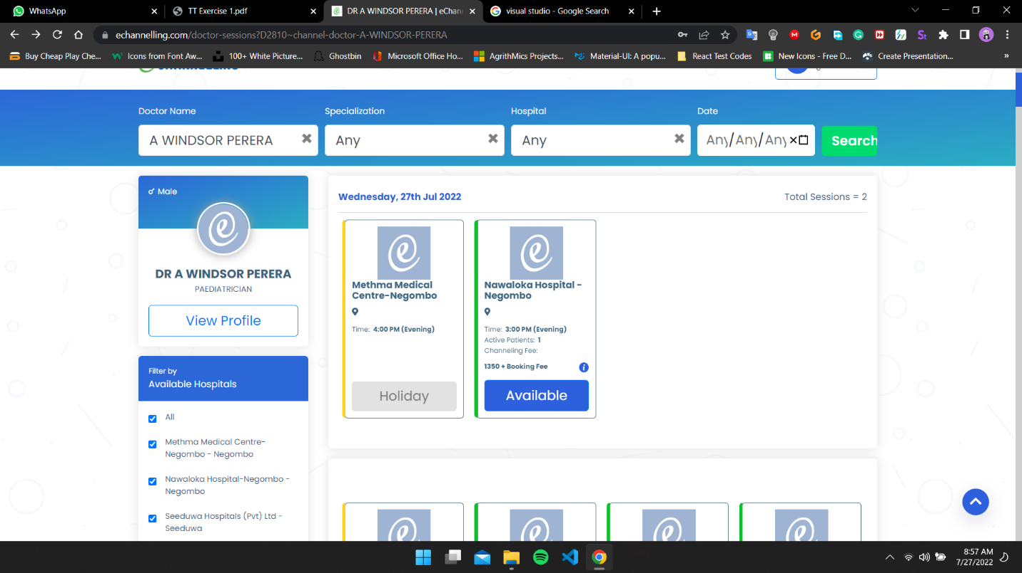This is the home page of e-Channeling website. From this page user can search doctor names.

This is the selected doctor page. From this page user can check the availability of the doctor.

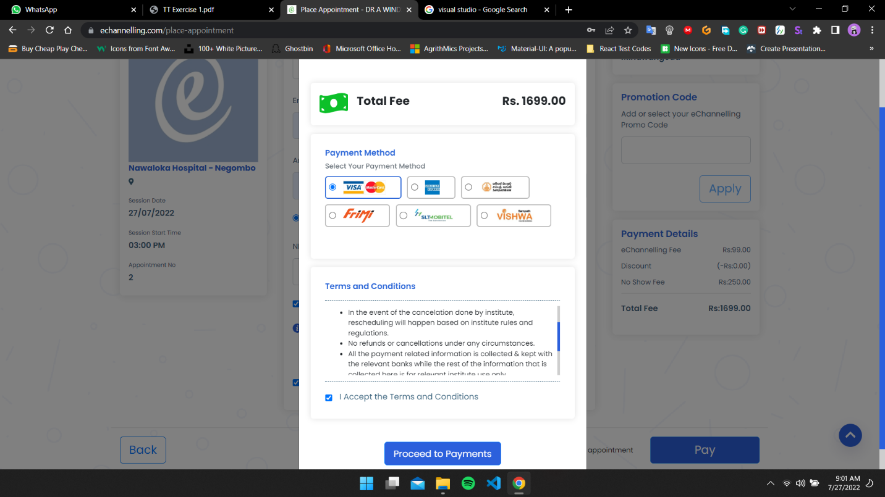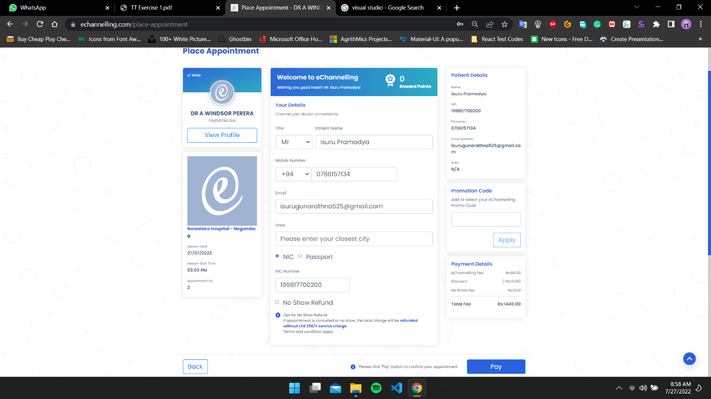Place Appointment Page- From this page user have to fill the user details and accept terms and conditions.

Payment Method Window- After Clicking Pay button system will pop-up window to select the payment method of the user.

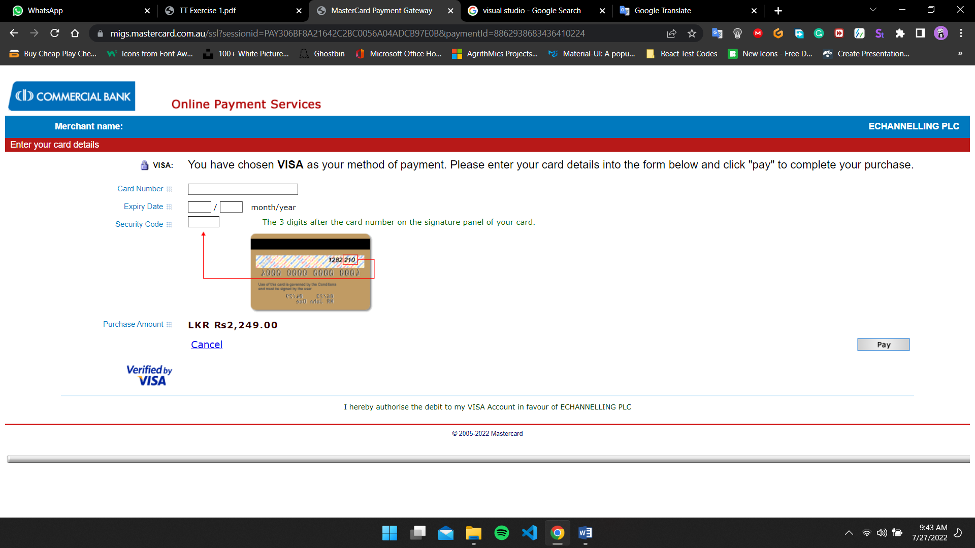Online Payment Gateway Page- After Clicking Proceed to payment button system will navigate user into Online payment Gateway page.

1. Web Solution
   1. Appointment ID
   2. Patient Name
   3. Patient Mobile Number
   4. Patient Email
   5. Patient NIC
   6. Payment Amount
   7. Doctor Name

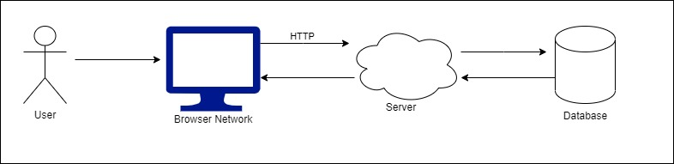

1. Yes
   1. Adding Doctors
   2. Maintaining the advertisements
   3. Confirming Doctor Verification
   4. Confirming the doctor verification
   5. Finding the location of the medicine deliver.
   6. Create a method to verify doctor details automatically.
   7. Creating a tracker system to find the delivery man location